WIX1002 Fundamentals of Programming
Tutorial 1 Problem Solving in Programming

Draw the Input Process Output (IPO) model and build the pseudocode, flow chart for each of the problems:

Part I

- Request two numbers from the user and print the multiplication of the numbers.

Input | Processing | Output
- Two numbers | - Multiply the number | - Product of the two numbers

Pseudocode:
Get two numbers from the user
Multiply the two numbers
Print the product

Flowchart:
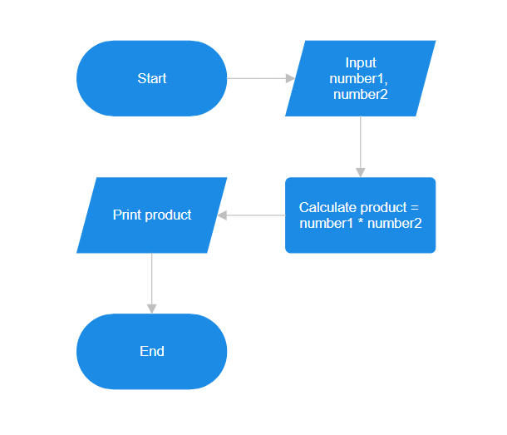
- Determine whether a random number is greater than 50.

Input | Processing | Output
- Random number | - Generate a number  - Compare it with 50 | - Message telling if the number is greater than 50 or not

Pseudocode:
Get a random number from the user
If number is greater than 50
Print “Your number is greater than 50”
Else
Print “Your number is less than or equal to 50”

Flowchart:
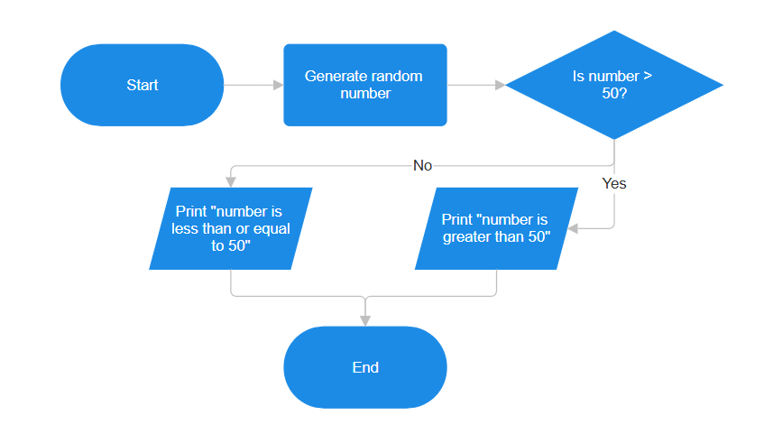
- Print the pass/fail grade based on the mark entered by user. The passing mark is at least 40.

Input | Processing | Output
- Mark | - Read the mark  - Compare it with 40 | - Pass or Fail grade

Pseudocode:
Get a mark from the user
If mark is >= 40
Print “Pass”
Else
Print “Fail”

Flowchart:
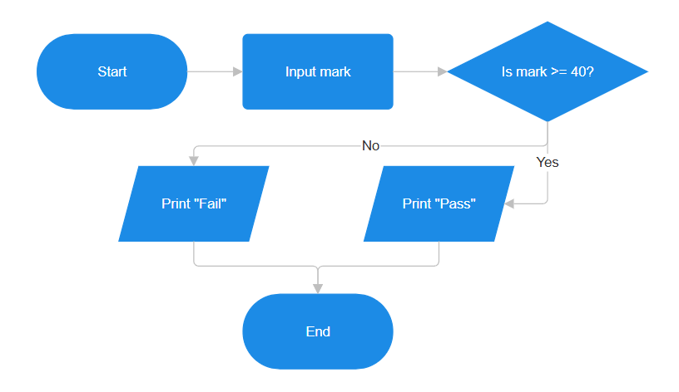
Input Mark
- Print the results of the two players’ dice game.

Input | Processing | Output
- Player 1 dice roll  - Player 2 dice roll | - Generate two random dice roll  - Compare player 1 with player 2 dice | - Winner of the game or a tie

Pseudocode:
Generate a random dice roll for Player 1
Generate a random dice roll for Player 2
If Player 1 > Player 2
Print “Player 1 wins!”
Else if Player 1 < Player 2
Print “Player 2 wins!”
Else
Print “Tie!”

Flowchart:
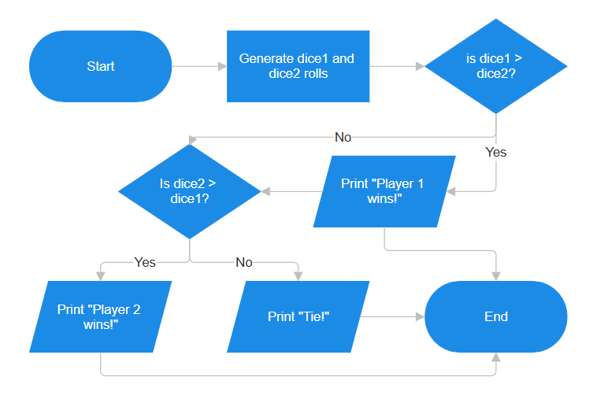
- Print the perimeter of a rectangle.

Input | Processing | Output
- Length  - Width | - Calculate perimeter = 2*(length + width) | - Perimeter of the rectangle

Pseudocode:
Get length from the user
Get width from the user
Calculate perimeter = 2*(length + width)
Print perimeter

Flowchart:
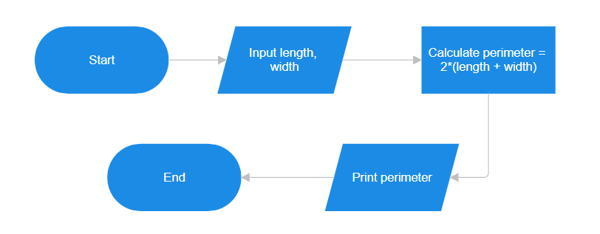
- Print the minimum number from 10 random numbers generated by computer.

Input | Processing | Output
- 10 random number | - Generate 10 random number  - Determine the minimum among the 10 numbers | - Minimum

Pseudocode:
Generate a random number
Initialize totalCount as 0
Set minimum = number
While totalCount < 9
Generate a random number
If number < minimum
Set minimum = number
Increase totalCount by 1
Print minimum

Flowchart:
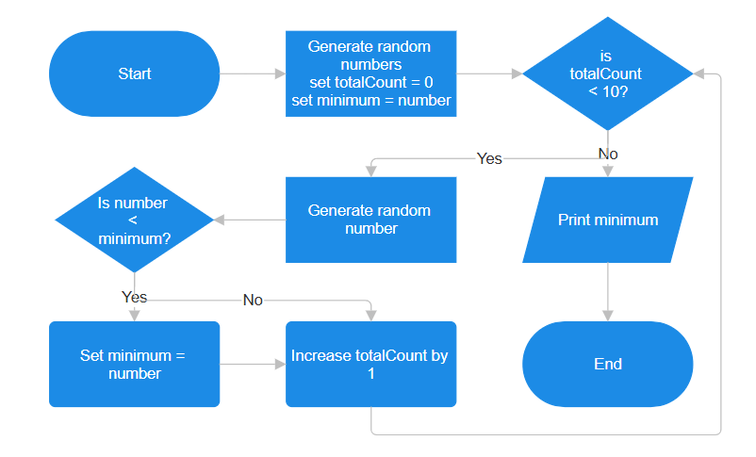
- Print the number of odd and even number from 10 random numbers generated by computer. The random number must be from 10 – 100.

Input | Processing | Output
- 10 random number from 10-100 | - Generate 10 random numbers from 10-100  - Determine the total number of odd and even  - Count the total of odd and even numbers | - Total count of odd and even numbers

Pseudocode:
Initialize totalCount as 0
Initialize oddNumber as 0
Initialize evenNumber as 0

While totalCount < 10
Generate a random number from 10 to 100
If number is divisible by 2
Increase evenNumber by 1
Else
Increase oddNumber by 1
Increase totalCount by 1
Print oddNumber
Print evenNumber
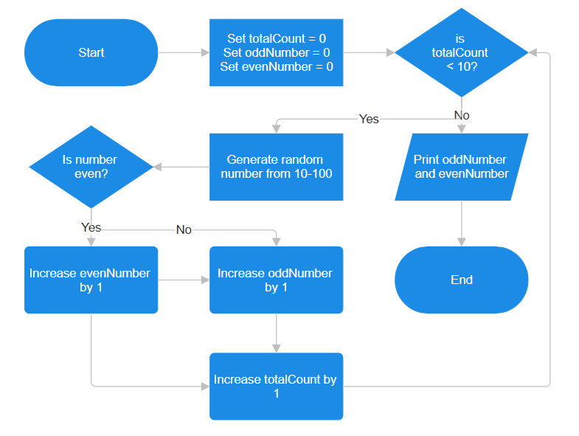

Flowchart:

Part II

- Count the number of alphabet U and M from a sentence entered by user.

Input | Processing | Output
- Sentence | - Read each letter from the sentence  - Compare character with letter U and M  - Count the letter U and M | - Total number of U and M

Pseudocode:
Get a sentence from the user
Initialize alphabetU as 0
Initialize alphabetM as 0
Initialize index as 0
While index < total number of letter
Read letter according to index
If letter is U or u
Increase alphabetU by 1
Else if letter is M or m
Increase alphabetM by 1
Increase index by 1
Print alphabetU
Print alphabetM
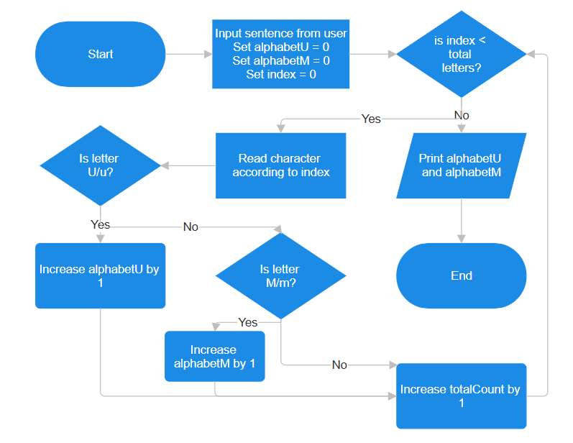

Flowchart:

- Display the frequency of a keyword from a web page.

Input | Processing | Output
- Keyword  - Web page | - Read the web page word by word  - Compare word with the keyword  - Count the matches | - Frequency of the keyword

Pseudocode:
Get keyword from the user
Get text content from the webpage
Initialize totalCount as 0
Initialize index as 0
While index < total number of words
Read the word according to index
If word is equal to the keyword
Increase totalCount by 1
Increase index by 1
Print totalCount

Flowchart:
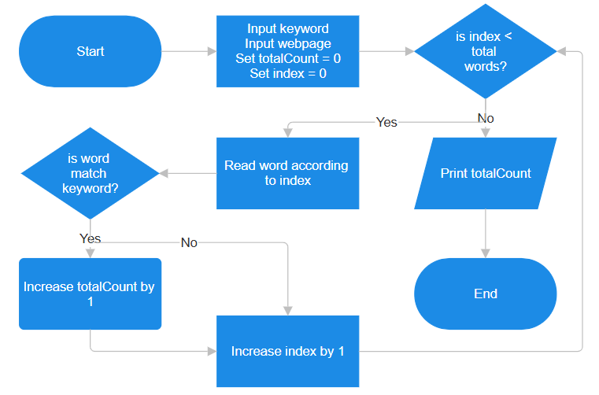
- Display the number of female student from a random list of 100 students.

Input | Processing | Output
- Generate list of 100 students along with gender | - Read each student gender  - Count total of female students | - Total of female students

Pseudocode:
Get random list of 100 students
Initialize totalFemale as 0
Initialize index as 0
While index < 100
Read student’s gender according to index
If student’s gender is female
Increase totalFemale by 1
Increase index by 1
Print totalFemale

Flowchart:
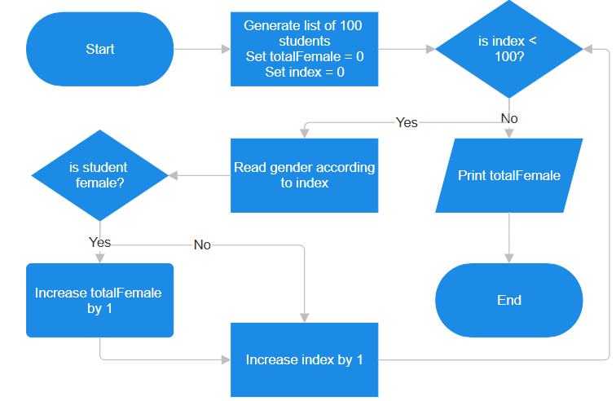
- Display a list of 5 random numbers in descending order. (Sort)

Input | Processing | Output
- Five numbers | - Generate 5 random numbers  - Sort number from biggest to smallest | - Random numbers in descending order

Pseudocode:
Generate a random number
Initialize totalCount as 0
Set highest = number
While totalCount < 5
Generate a random number
If highest < number
highest = number
Increase totalCount by 1
Print list

Flowchart:
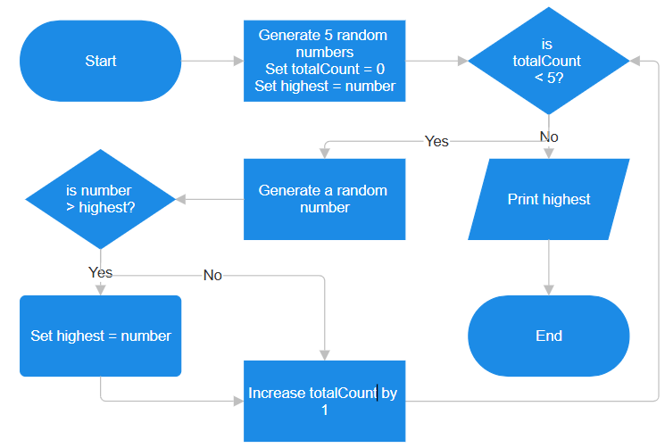
- Guess a random number generated by computer.

Input | Processing | Output
- Guess | - Generate random number  - Check guess if matches with the random number | - The range of the guess and correct guess

Pseudocode:
Get a guess from the user
Generate a random number
While guess is not equal to the number
If guess > number
Print “Too high!”
Else
Print “Too low!”
Get a guess from the user
Print “Your guess is correct!”

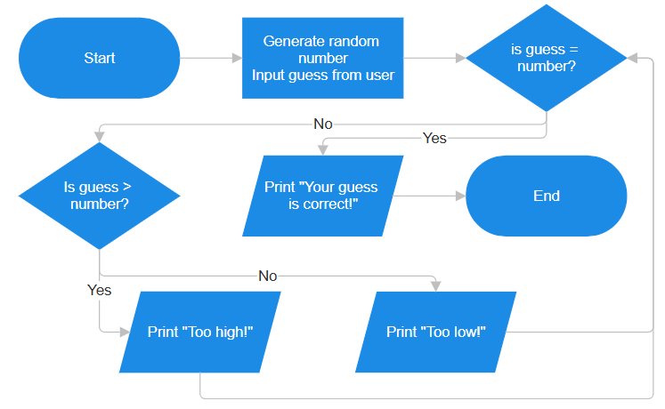
Flowchart:

